**REGISTER 1**  
**Register 2 starts on page 9.**   
New printer issues: Full Printer Manuals can be found on [KB0010129](https://hibbett.service-now.com/kb_view.do?sys_kb_id=80ba304d872bd1503ada4229dabb356b)

* We can’t use bigfix remote for this because of permissions issues, you will have to use RDP  
  Type RDP into your start menu to open Remote Desktop Connection  
  Enter the PC name and use **your windows credentials.**
* Prompt will appear asking if you want to connect while someone else is connected.  
  Click Yes- have the Store to ‘click OK on the screen when it asks you’  
  (alternative: use Big fix and click this yourself)  
    
   **INSTALLATION STEPS**
* In the RDP Session - Navigate to the G:\ drive since it maps to your windows login credentials  
  **Copy G:\helpdesk\printer drivers\DCP-L2550DW\** then Paste to **C:\dvinst\printers\**  
  Open up the folder you just pasted and run the executable inside, this will extract the driver installation files to a ‘gdi’ folder which we target when we install the printer.  
    
   *****Assuming the store does not already have the driver installed (Hibbett)*****
* Open a windows explorer or command prompt and type ‘control printers’ into the address bar.  
    
  You’ll notice the printer does not show up as an unspecified device.  
    
  Click on any of the printers and choose Printer Server Properties  
  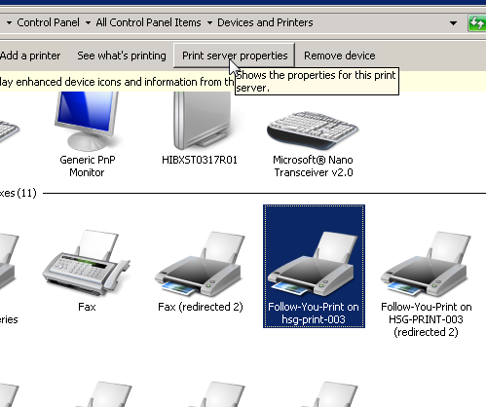
* Select the Drivers tab

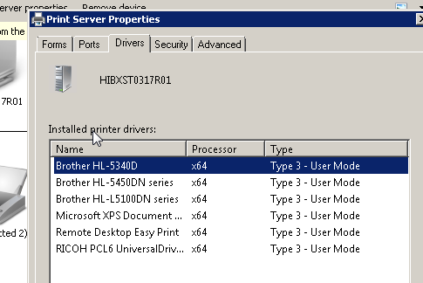

* If the DCP-L2550DW driver is not listed, add using the following steps.  
  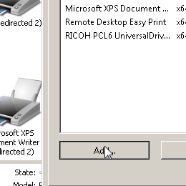 Graphical user interface, text, application

  Description automatically generated  
    
  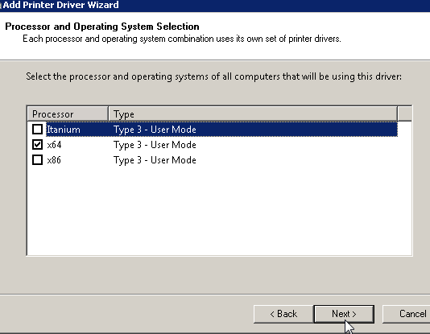 Graphical user interface, text, application

  Description automatically generated  
    
  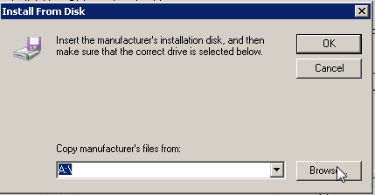
* **Browse** to the gdi folder that was created earlier in **C:\dvinst\printers\DCPL-L2550DW**  
  You need to select on of the *inf files appearing in this window.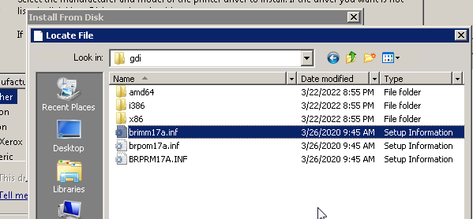
* Scroll down and find the driver for Brother -DCP-L2550DW and click next

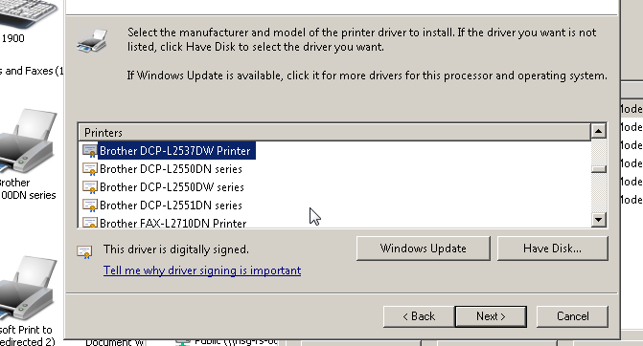

* Select Finish

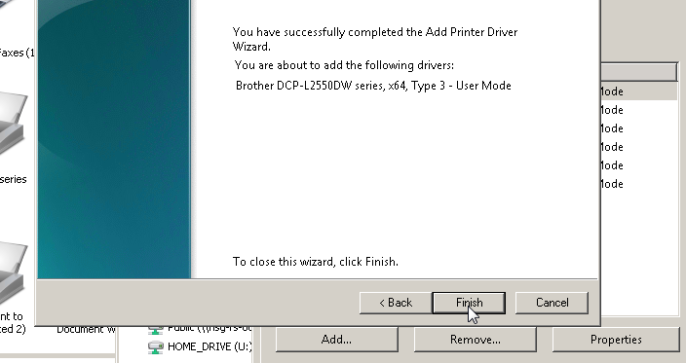

* Once the driver is installed you will see ‘dcp-l2550DW series’ under unspecified devices  
  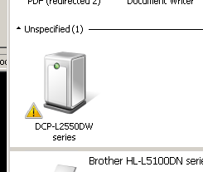
* Right click the unspecified devices (screen shot in previous step) and Go to the Hardware tab. Highlight the first 2550dw device on the list (**This is the scanner device that comes as part of the printer)**
* Select properties and select update driver  
  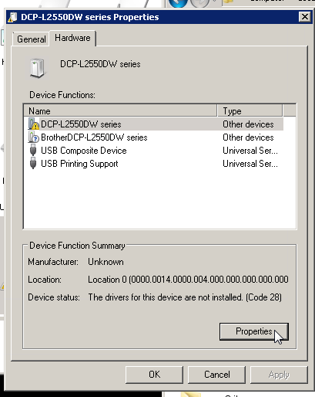 Graphical user interface, application

  Description automatically generated  
    
  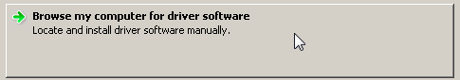  
    
  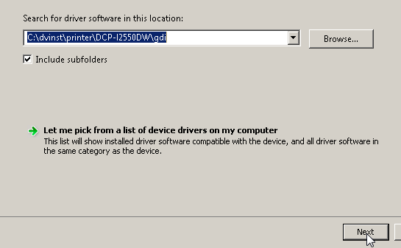 Select Next if the above folder is the one entered. If not type it in, or browse to it and select it.
* The scanner driver will then install  
  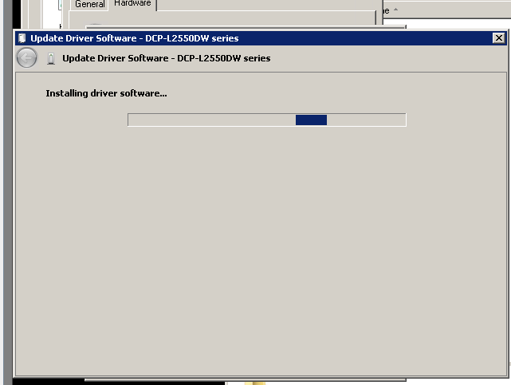
* Once installed close the following windows.   
  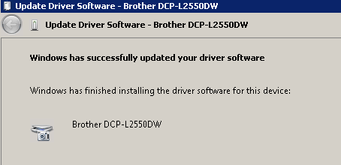 Graphical user interface, application

  Description automatically generated  
    
  You will then see the scanner listed as a device  
  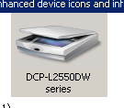
* Install the driver for the next device in the list with the same steps as above.  
  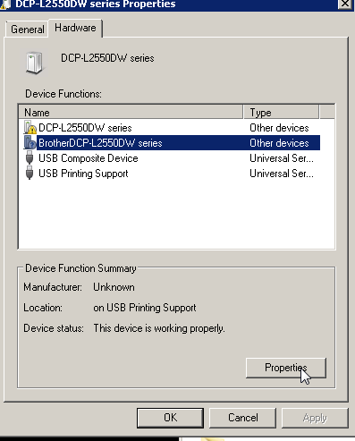A picture containing diagram

  Description automatically generated
* **SETTING PRINTER AS DEFAULT AND SHARING THE PRINTER**  
    
  Now you need to set it up as their default printer. Right click printer > Set as default  
  You need to setup the printer.  
    
  Right click printer > Printer properties > Sharing tab > **Apply the changes**  
  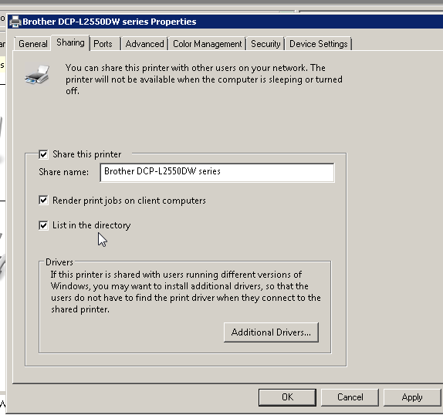  
    
  Since the install was successful, we need to delete the old printer.  
  *(If you do not have psexec setup on your machine, you will need it installed for printerdel.bat to work. Reach out to the team for guidance.)*  
    
   ****Now end your Remote desktop session and Go into the register using Bigfix****  
    
  Run G:\Helpdesk\helpdeskscripts\printerdel.bat on your machine > Follow the instructions and refer to below   
    
  **Shortcut for name:**  
  I like to go to explorer , type ‘control printers’ and right click the **OLD PRINTER** and choose ‘printer properties’  
    
  From here you can copy the name..  
    
  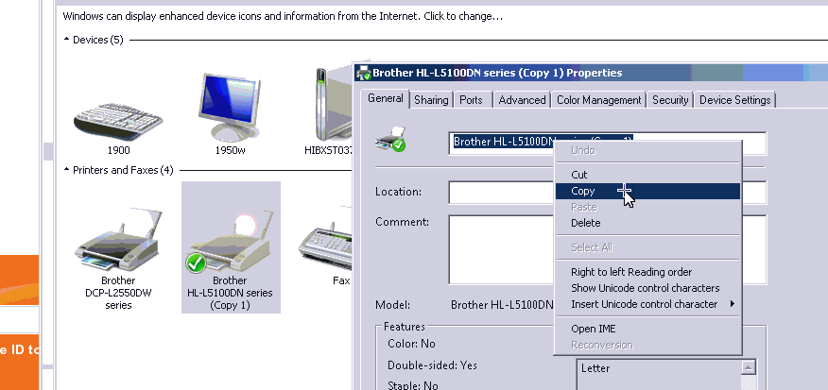
* Now you can use Bigfix’s tools to ‘pull clipboard text’  
  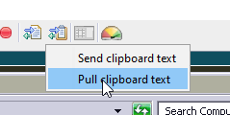
* Right click printerdel.bat when it is asking for the name, it should auto-paste it in….. if not….. you have to type it out yourself.  
    
  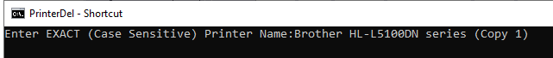  
    
  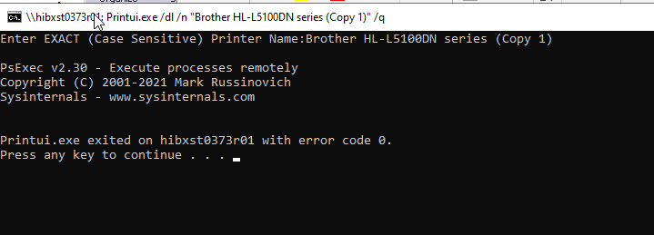  
    
  Exit with Code 0 and you’re good to go, printer was deleted.
* **Make the new printer the default (Must be changed as Xstore user.. via the normal BIGFIX.)**  
    
  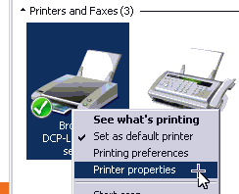
* Warning Sharing issue…  
    
  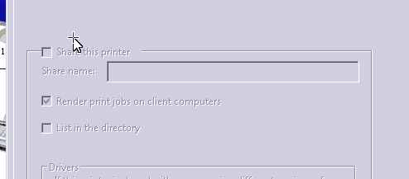  
  If you try to share it and it looks like this………You forgot to share in RDP, Go back in RDP and share it then.  
  Reminder: *You need to ask them to open an e-mail or browser and try to print. The default printer for the browser will not have changed for R1, Try to print the e-mail/page and then click the drop down in the pre-print menu. Choose ‘See More’ and choose the DCP-L2550DW.*  
    
  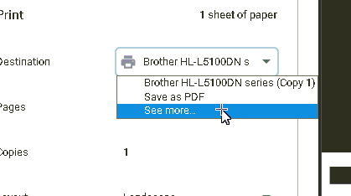

Select the new printer.  
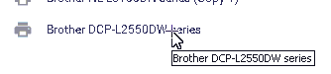

**REGISTER 2**  
  
After setting up R1 and sharing. You need to install the driver on R2. **The instructions for R2 driver are the same as those for R1 except you do not have to complete the scanner.**   
 *****Don’t forget to Remove the old printer from R2*****

* Remove from R2 by right clicking,  
   (printerdel.bat is not needed here.)  
  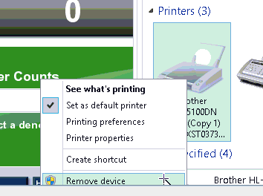
* To map the shared printer, navigate to ‘network’ in file explorer and wait for the pc’s to appear. **Double click R1 > Right click Printer > Connect.**  
   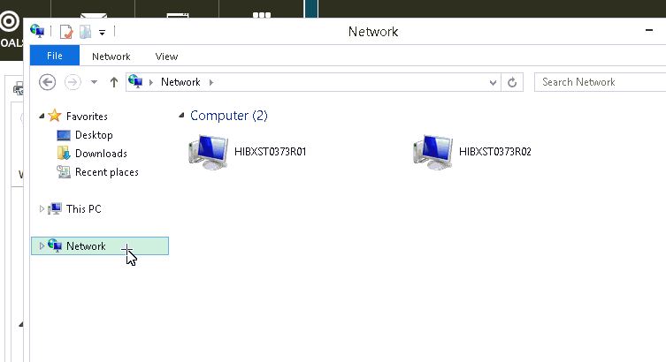 Graphical user interface

  Description automatically generated
* If the network devices do not show as above immediately, wait or map them manually in control panel

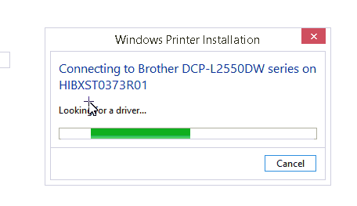

Warning: If you get this response.  
  
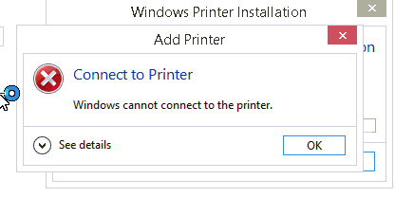  
Two Possible Causes:  
  
1. Driver was not installed via RDP to R2.  
  
2. Security patch issue, Printer Nightmare update needed on both registers. if both registers do not both have the update you will likely have this issue.  
  
  
This is also common after register swaps  
  
Push the Windows critical POS updates for Microsoft and .net  
Push: windows 8 to R2 and Windows 7 to R1. I do both for good measure.  
Just search ‘critical’ in the BigFix to find.